I was lucky enough to live in St Ives for many years as a young girl and better still, be the daughter of a talented woman who was very much a part of the incredible art scene that was, ‘back-in-the-day’. It was a wonderful life.

At the age of 21, I moved to London and then on to the USA but each and every year I came back to St Ives to stay with my sister, her husband and their two boys who have always lived in the town.

It was in my early 40s that I made the decision to ‘come home’. I could never have imagined however what would transpire following the move, but 8 years ago I happened across a first love and he and I along with his beautiful daughter have since enjoyed a lovely family life.

So fast-forward to today. Now in my 50th year - we all find ourselves on the cusp of realising a wonderful opportunity to build a family home from the ground up.

Aucklands came into our lives when, whilst renting a cottage in St Ives and on a winter’s day's walk, we noticed the house was up for sale. We were giddy with excitement and it was only within a matter of a few days that the property was viewed and an offer was put in and accepted.
My Dad, a retired architect, who worked locally for much of his career, has influenced me over the course of my lifetime and his love of modern architecture in particular is something that I too have appreciated over the decades. Added to this, my passion for interior design; it most definitely went without saying that our new home would be re-designed with much thoughtful consideration.

Of course it was with great regret that we decided it made no real sense to renovate the house as we had first intended (as communicated in the JDA Statement) but instead a new build was the way forward.

Dad was instrumental in the development of the initial design and like Christian has so artfully described, Pierre Koenig’s Case Study 22, the Stahl House has been the focus of our inspiration throughout this process.

The plot on which we stand so perfectly lends itself to an L-shaped home and its basic shape quickly became, in simple terms, two white boxes adjoined by a third box made of glass. Windows would appear as a result of their proper placement internally and really it was only the building’s interior make-up that required much more time, effort and energy.

It was necessary to understand how space could and should be best utilized. We wanted to be creative and think long and hard about each aspect of the building’s internal configuration. We spent time thinking about our needs as individuals as well as a family unit. And importantly, we thought not only of today, but also the long-term future.

This will have been our 5th year in the caravan! We have been stationed here in our back garden and we have learned all that is possible to learn about this plot. Where the sun comes up throughout the year. How the sun moves around the plot. Where the sun sets. We have watched the moon, big and small. We have stared at the sea in the winter and at the trees in the summer. We have watched season upon season; trees, shrubs and flowers thrive and then subside. And we know when and why we will hear the train hoot or the church bells ring or the sea crash on the shore. This home, that we have all as a collective helped design, has been imagined with much love and understanding. And we could not be happier about its location in our beautiful town St Ives, a town that came into my life when I was the tender age of two.

Although I appreciate that this design might not be for all, I hope that the town of St Ives and its residents can at least recognise that there is a strong intention on our part to create a building that has architectural merit.

Not to say that what we have provided here in this application really is anything that new. The great and the good were creating ‘modern' architecture approaching 100 years ago. Take Ludwig Mies van der Rohe (March 27, 1886 - August 17, 1969) and his Barcelona Pavilion, constructed in 1929 and shown in the image below.

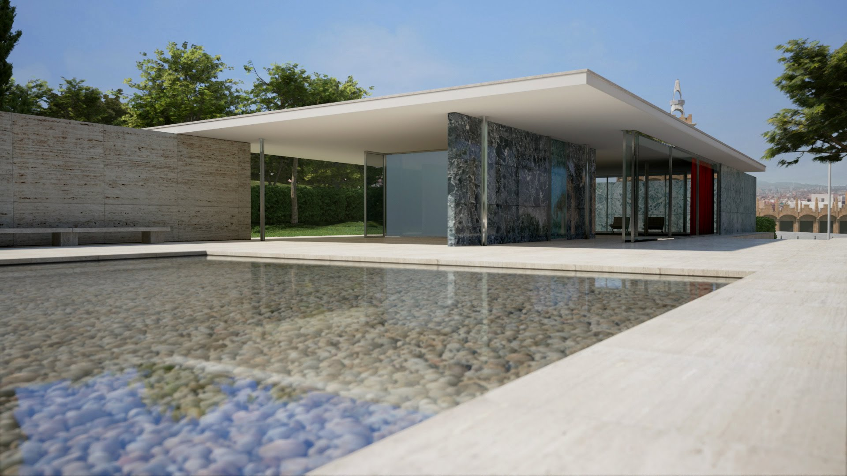

Before closing I could not talk about this build without mentioning our huge gratitude to my Mum, who has played a very generous part in helping us realise this dream of an opportunity.

And in closing, we plan to change the name of the house following its completion to ‘Honey House’, as a way of recognising the family that once had commissioned the construction of Aucklands, where the Honey children were born and where the original Honey owners stayed until their passing.

We thank you all for your generous consideration.

